Your University at your side

Mental Health and Wellbeing at the University of Wolverhampton:
- provide free and confidential individual counselling
- offer non-judgemental support and understanding
- are professionally trained
- are experienced in dealing with a wide range of problems
What stops men seeking help?
An introduction to counselling for men

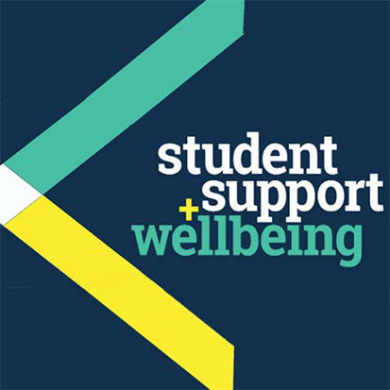
Counselling can:
What stops men seeking help?
- help you to develop your strengths
- offer you the chance to focus on and understand your difficulties
- enable you to make positive decisions and changes
- help you to develop the skills and resources to cope
- help prevent small problems from becoming bigge.r

Get in touch
You can make an appointment to see a counsellor by filling out the Contact Us form at www.wlv.ac.uk/SSW, alternatively, you can come along to one of our drop-in services. For more information go to the web address above and click on the Mental Health and Wellbeing option. From here you will find a wealth of useful information and self-help tools as well as our Drop-ins and Group activities.

University Mental Health & Wellbeing

Common misconceptions on being a man
“Men aren’t supposed to have problems – it’s a sign of weakness.”
“Men are meant to deal with problems themselves.”
“Men should appear strong, intelligent and capable.”
“Men should take care of others.”
“Men aren’t supposed to be scared or embarrassed.”

Common feelings of embarrassment
“I couldn’t talk to my doctor – it’s too personal.”
“I wouldn’t be taken seriously, I’d probably be laughed at.”
“I feel so stupid – others don’t feel this way – they don’t have the same problems.”
“If my mates knew, I’d be ridiculed.”

What gets in the way?
The biggest obstacle for a man seeking help is most probably his fear of what others might think.
Consequently, when a man really does need help he leaves it until the very last minute, by which time he has put up with the problem for much longer than needed. Keeping things to ourselves may make things worse in the long-term.

Typically, men make light of their problems in conversations with friends or partners. Their reluctance to seek help is shown in a survey showing men’s attitudes about accessing medical help. For example, embarrassment is preventing 31% of men from seeing their doctor*.
*Institute of Cancer Research, 2001

Things you can do
- Talk to someone you trust about the problem – taking small, manageable steps like this may well relieve you. Often other male friends have similar thoughts.
- Describe in writing what the problem is, how it feels, what your thoughts are about it – this can help you make sense of things and think clearly about what the problem is.
- See your doctor – if you feel uncomfortable with your own doctor, ask to see another.
- Consider talking to a counsellor.

Concerns
Men who seek help from the University Counselling Service bring a variety of concerns, including:
- lack of motivation and difficulties in concentrating on work or academic studies
- relationship breakdown
- depression and anxiety
- sexual concerns
- sexual identity
- eating disorders, often related to body image
- a new role in the family
- fear of failure
- drug use and alcohol consumption
- stress and pressure
- anger management.

Counselling
During counselling sessions, you can talk to someone confidentially who is ‘neutral’ and independent. Perceptions about counselling vary from person to person. Here are some common misconceptions:
- it’s not really confidential
- it’s only for people with serious mental problems
- talking about how I feel is a sign of weakness
- it’s shameful to talk about myself outside my family.
In reality, talking to someone in a non-judgemental capacity can actually bring a variety of beneficial outcomes:
- relief: getting things off your chest
- space to think straight
- sharing thoughts and feelings, and thereby easing the burden
- fresh perspectives
- greater ease in talking to someone you don’t know
- development of strategies for dealing with problems and feelings
- feeling more confident in yourself and your decisions
- feeling that things are more manageable.
Men who have accessed help will often say that they wished they had got support earlier. They say that asking for help wasn’t such a big deal after all.

“I feel able to cope with situations better, and I feel more in control of myself – it helped me to think straight.”

People you might want to contact:
- Your doctor
- NHS 111 – tel: 111
- Beating Eating Disorders helpline on tel: 0845 634 1414 or visit: www.b-eat.co.uk
- The Samaritans – tel: 08457 90 90 90
- Survivors UK – help for men who have been sexually abused or raped: www.survivorsuk.org 0845 122 1201

Other useful websites:
The Royal College of Psychiatrists

www.rcpsych.ac.uk/mentalhealthinfo.aspx

MIND mental health organisation www.mind.org.uk/ information
Family doctor - online health resource with some specific information for men www.familydoctor.org

Free meditation exercises: http://franticworld.com/ free-meditations-from-mindfulness/

