Help with different types of abuse

Your University at your side
Mental Health and Wellbeing at the University of Wolverhampton:
- provide free and confidential individual counselling
- offer non-judgemental support and understanding
- are professionally trained
- are experienced in dealing with a wide range of problems
Counselling can:
- help you to develop your strengths
- offer you the chance to focus on and understand your difficulties
- enable you to make positive decisions and changes
- help you to develop the skills and resources to cope
- help prevent small problems from becoming bigge.r

Get in touch
You can make an appointment to see a counsellor by filling out the Contact Us form at www.wlv.ac.uk/SSW, alternatively, you can come along to one of our drop-in services. For more information go to the web address above and click on the Mental Health and Wellbeing option. From here you will find a wealth of useful information and self-help tools as well as our Drop-ins and Group activities.
Help with different types of abuse

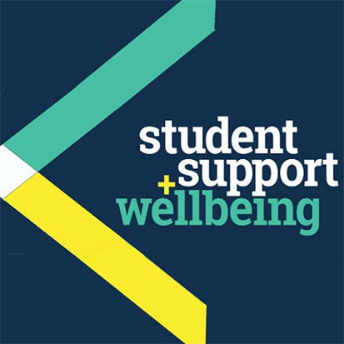

University Counselling Service

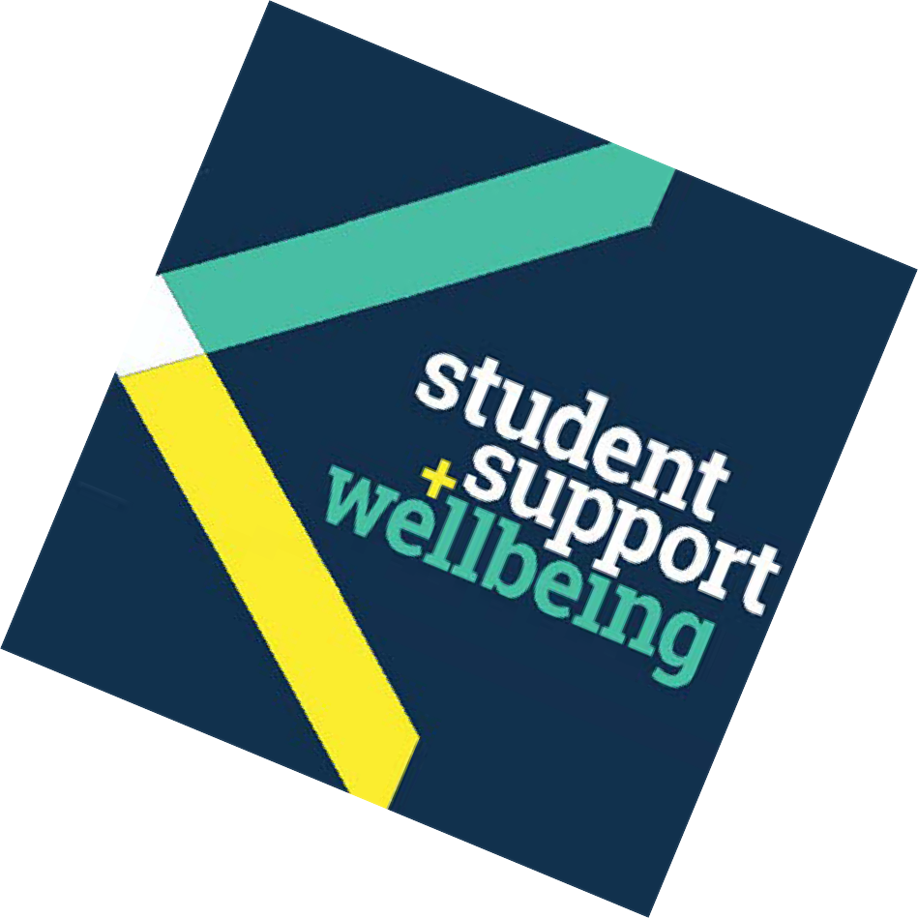What is abuse?
More and more there is talk about ‘abuse’. Finally, some people are feeling more able to talk about what has happened, or is happening, to them, and feel heard.
Abuse can take many forms (physical, emotional, psychological and sexual) and includes both physical and emotional neglect eg. not meeting a child’s basic needs for warmth, care and nurture. When one form of abuse exists, it is often coupled with others. Men and women from all backgrounds abuse and are abused.

Physical abuse
Physical abuse is the most visible; it involves behaviour which harms, or is intended to harm someone.
One form of physical abuse is domestic violence. It’s widely recognised that women with male partners may experience domestic violence; other sufferers (men with female partners and men or women in same sex relationships) may be less visible.
As the severity and frequency often increases over time, it is important that individuals in these circumstances access the help and support that is available to them.

Emotional and psychological abuse
The majority of emotional and psychological abuse is more subtle and therefore is often not recognised as such. For example, a parent
or partner may continually withhold love and support or constantly criticise and belittle a person. Such behaviour can seriously damage an adult or child’s self esteem.

Sexual abuse
Sexual abuse involves any non-consenting sexual act or behaviour. It inevitably contains aspects of physical, emotional and psychological abuse. Such abuse can have a lasting effect and impact upon various aspects of adult life.

Flashbacks or memories
If we’ve experienced or witnessed abuse, we may have flashbacks or memories of former events which, for good reason, we’ve put ‘out of our mind’. Unexpectedly, something such as a TV programme, newspaper article, a tune, or a smell, can trigger flashbacks and catch us unawares. The fact that we’re becoming aware of them may be an indication that we are now able, with appropriate support, to face and come to terms with our past.

What can help? Breaking the silence
Each of us has a story to tell; ‘breaking the silence’ by talking in confidence to a professional counsellor, who is trained to listen, can help enormously.

Breaking patterns
Childhood experiences can set patterns and may influence how we relate to others in our adult lives. We may find ourselves repeatedly involved in relationships of an abusive nature.
Exploring these issues with a counsellor can help us to understand ourselves and our situations better and also support us as we initiate any changes that we may wish to make.

Keeping ourselves safe
It can be hard to leave an abusive relationship. People stay for various reasons eg. feeling dependent upon a partner who has withheld money or isolated them from friends and family; fearing losing custody of children; there may be good times in between incidents of violence; or they may be unaware of sources of safety and support (see opposite for further information).

You might like to read:
Bass, E. and Davis, L. (2008) The Courage to Heal – A Guide for Women Survivors of Childhood Sexual Abuse, New York: HarperCollins
Maltz, W. (2012) The Sexual Healing Journey - A guide for Survivors of Sexual Abuse (Third Edition), New York: HarperCollins
Walker, M. (1992) Surviving Secrets, Buckingham: Open University Press

People you might want to contact:
- Your doctor
- NHS 111 – tel: 111
- The Samaritans – tel: 08457 90 90 90 or visit:
www.samaritans.org.uk
- Hidden Hurt: domestic abuse information – visit: www. hiddenhurt.co.uk
- Women’s Aid – 24 hour Domestic Violence Helpline – tel: 0808 2000 247 or visit: www.womensaid.org.uk
- Refuge: provides aid and refuge to women and children – tel: 0808 2000 247 or visit: www.refuge.org.uk
- Survivors UK: help for men who have been sexually abused or raped – tel: 0845 122 1201 or visit: www.survivorsuk.org
- Men’s Advice Line: help for men in abusive relationships – tel: 0808 801 0327 or visit: www.mensadviceline.org.uk

Other useful websites:
The Royal College of Psychiatrists
www.rcpsych.ac.uk/healthadvice/atozindex.aspx
Advice from Mind:
www.mind.org.uk/information-support/mental-health-a-z/
Useful leaflets:
www.ntw.nhs.uk/pic/selfhelp/
Health A-Z at:
www.nhs.uk
Free meditation exercises: http://franticworld.com/free-meditations- from-mindfulness/

