Other useful websites:

The Royal College of Psychiatrists
www.rcpsych.ac.uk/healthadvice/atozindex.aspx

Advice from Mind:
www.mind.org.uk/information-support/mental-health-a-z/

Useful leaflets:
www.ntw.nhs.uk/pic/selfhelp/

Health A-Z at:
www.nhs.uk
Free meditation exercises: http://franticworld.com/free-meditations- from-mindfulness/

Your University at your side

Counsellors at the University of Wolverhampton:
- provide free and confidential individual counselling
- offer non-judgemental support and understanding
- are professionally trained
- are experienced in dealing with a wide range of problems

Counselling can:
- help you to develop your strengths
- offer you the chance to focus on and understand your difficulties
- enable you to make positive decisions and changes
- help you to develop the skills and resources to cope
- help prevent small problems from becoming bigger.

Get in touch
You can make an appointment to see a counsellor by filling out the Contact Us form at www.wlv.ac.uk/SSW, alternatively, you can come along to one of our drop-in services. For more information go to the web address above and click on the Mental Health and Wellbeing option. From here you will find a wealth of useful information and self-help tools as well as our Drop-ins and Group activities.

Anxiety and panic attacks
A guide to help you become less anxious

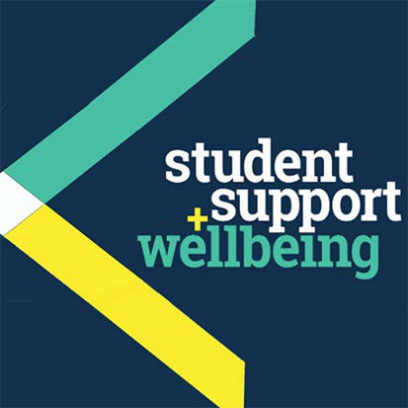

University Counselling Service
Anxiety and panic attacks

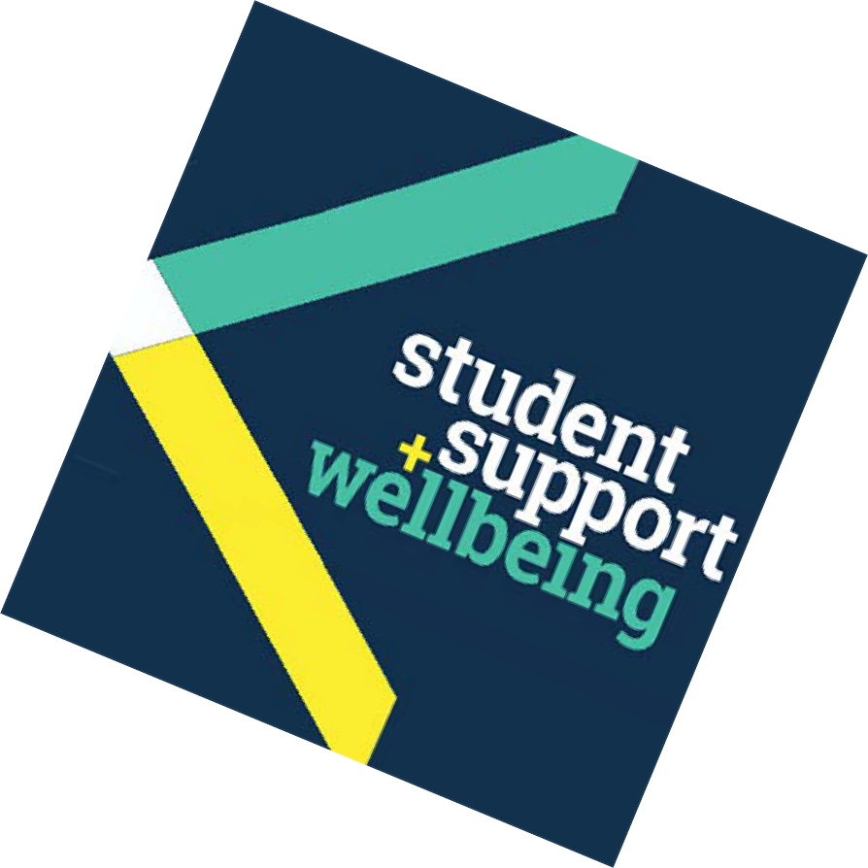What is anxiety?
Anxiety is a normal reaction to a situation that we may perceive as challenging, difficult or stressful.
Although anxiety has a healthy purpose, helping us to avoid dangerous situations, anxiety can at times become excessive and unhealthy. It is at these times that you may need to seek help or support in managing your anxiety.

Causes of anxiety
Anxiety can be caused by external demands or situations, such as environmental, financial or social circumstances or other uncertainties. It can also be caused by internal expectations, attitudes or demands we place on ourselves.
Anxiety can affect us:
- emotionally (what we feel and think)
- physically (changes within our bodies)
- behaviourally (what we do and how we act)

Symptoms of anxiety
The most significant symptoms that you may experience are fear and worry. Additional symptoms that may follow are listed below and can vary in intensity and length.
Emotional symptoms:
- confusion
- worry
- dread
- apprehension
- unease
- poor concentration
- irritability
- tearfulness
- feeling out of control
Physical symptoms:
- racing heartbeat
- sweating
- cold, clammy hands
- headaches
- fatigue
- dizziness
- shortness of breath
- sleep and appetite disturbance

Behavioural symptoms:
- being argumentative
- increased aggression
- rushing around
- avoiding or escaping social situations

Overcoming your anxiety
Understanding where your anxiety is coming from will help you to control and reduce it. You may want to see a counsellor to get help with this.
Here are some further steps for reducing anxiety.
- Take up physical exercise or a new hobby – do something you will enjoy!
- Distraction techniques can help eg. focusing on an object and describing it in detail (shape, size and colour) or imagining pleasant situations, either remembered, or fantasies of your own making.
- Manage your time better, and take some time out of the day to devote to yourself.
- Challenge your negative thinking – be aware when you use words such as ‘must, ‘should’ and ‘ought’.
- Express yourself! Be more open about your feelings rather than bottling things up.
- Avoid alcohol and/or drugs. Either can make your stresses and problems worse in the long term.
- Talk about it – with friends or those you feel close to and trust.
- Try eating more healthily and keeping a regular sleeping pattern – healthy and routine patterns will help your body deal with anxiety better.
- Try some mindfulness techniques (see under ‘Other useful websites’ for details).

Panic attacks
A panic attack describes an episode of intense anxiety. As mentioned earlier, anxiety develops more gradually, is less intense and lasts longer than a panic attack.
The symptoms of a panic attack usually develop abruptly, peak at around 10 minutes, and generally end within 20-30 minutes.

Symptoms of a panic attack
- Chest or stomach pain
- Heartburn
- Shortness of breath
- Dry mouth and throat
- Palpitations/ racing heartbeat
- Thoughts of dying
- Excessive sweating
- Dizziness, trembling
- Nausea and vomiting
- Numbness and tingling

Coping with a panic attack
Controlled breathing is key – becoming aware of how you are breathing can slow down the panic attack. You can do this by breathing slowly through your nose and exhaling longer than you inhale.
Remind yourself that the panic attack will go away – it is not harmful, just unpleasant and uncomfortable as it is an exaggeration of our normal response to stress.
Divert your attention – think of something else. Concentrate on what is around you and become aware of your senses of smell, sight, sound and touch.
Think positively – repeat to yourself “I know I can get through this” and stop the ‘what if…’ thoughts which could heighten your negative feelings.

“[Counselling] has helped me to find out what exactly is causing my anxiety, and taught me to try and take my mind off it.”

People you might want to contact:
- Your doctor
- NHS 111 on tel: 111
- The Samaritans on tel: 08457 90 90 90
- No Panic support helpline, tel: 0800 138 8889, crisis number 01952 680 835 or visit: nopanic.org.uk

