RESEARCH CONFERENCE 2023 CALL FOR SUBMISSIONS

Aim and scope
The Faculty of Science and Engineering (FSE) at the University has a vibrant research community doing research in the areas of architecture and built environment, engineering, maths and computing, and science and pharmacy, as well as multidisciplinary research across subject
boundaries. Our research spans a whole spectrum of subjects including but not limited to: additive layer manufacture, animal behaviour, artificial intelligence, bio-degradable polymers, brownfield, chemistry, composite material, computing, cyber security, data science, energy, forensic science,
life science, management studies, oncology, pharmaceutical science, sustainability, smart cities, transport and infrastructure, water and wildlife conservation
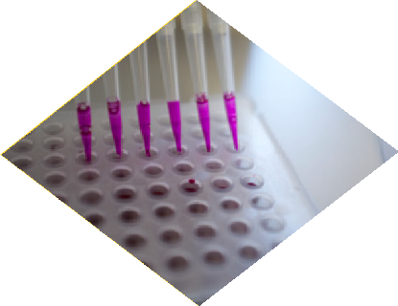 The conference is aimed at postgraduate
research students to encourage participation and to be part of the vibrant research community led by the Dean, Associate Dean of Research and Knowledge Exchange along with the Director of Postgraduate Research Programmes of FSE. The scope of this conference is to discuss FSE research projects and its link to the United Nations’ Sustainable Development Goals (SDGs).

Submission details
Researchers wishing to submit must choose a track and follow the guidelines (see next page).
Two tracks for submission:
Track 1: Extended Abstract - 1000 words Track 2: Full paper – 5 pages
Paper must be emailed to FSEResearchFestival@wlv.ac.uk by 12:00 noon 20th March 2023 with the subject: FSE FoR Conference 2023. When preparing your submission please remember that your audience is non-specialist and content should be accessible to the general public. Should you need to discuss, please feel free to contact Dr Subashini Suresh (s.subashini@wlv.ac.uk)

Key dates:
• Submission of Track 1 or Track 2 by: 20th March 2023
• Reviewer’s feedback on submission: 3rd April 2023
• Final submission on or before: 17th April 2023
• Conference dates: May 3rd and 4th May 2023

Paper guidelines
Please prepare your paper in Microsoft Word format using the following guidelines:

Article title | A title of not more than eight words should be provided.
Author details | Author name and supervisor team names  Current study year of PhD programme (1st, 2nd, 3rd, etc)
Structured abstract | Author must supply a structured abstract in their submission, set out under these sub-headings:  Abstract  Purpose (mandatory)  Design/methodology/approach (mandatory)  Findings (mandatory)  Research limitations/implications (if applicable)  Practical implications (if applicable)  Originality/value (mandatory)  Link to SDG (State which SDG the work fits into i.e. SDG 9 – Industry, innovation and infrastructure). For details of 17 SDGs visit: https://sdgs.un.org/goals  Extended Abstract – 1000 words  Full paper must have an abstract maximum is 250 words in total (including keywords). Followed by the main body of the paper
Keywords | Authors should provide appropriate and short keywords. The maximum number of keywords is 5 and should be placed in alphabetical order.
Main body of the paper | Introduction  Problem statement/motivation of the research  Methodology  Analysis and results  Discussions  Conclusions  References
Headings | Headings must be concise, with a clear indication of the distinction between the hierarchies of headings.  The preferred format is for first-level headings to be presented in bold format and subsequent sub-headings to be presented in medium italics.
Figures | All figures (charts, diagrams, line drawings, web pages/screenshots, and photographic images) should be submitted in electronic form.  All figures should be of high quality, legible, and numbered consecutively with Arabic numerals. Graphics may be supplied in colour to facilitate their appearance on the online database.
Tables | Tables should be typed and included in the main body of the paper. The position of each table should be clearly labelled in the body text of paper.  Ensure that any superscripts or asterisks are shown next to the relevant items and have corresponding explanations displayed as footnotes to the table.
References | References to other publications must be in Harvard style and carefully checked for completeness, accuracy, and consistency.

